William Chengyu Zhang

cz1627

Decoding Nature

Final Project Proposal

For the final project, I intend to create a web-based geometric pattern that changes with user movement and voice. Here is the draft: 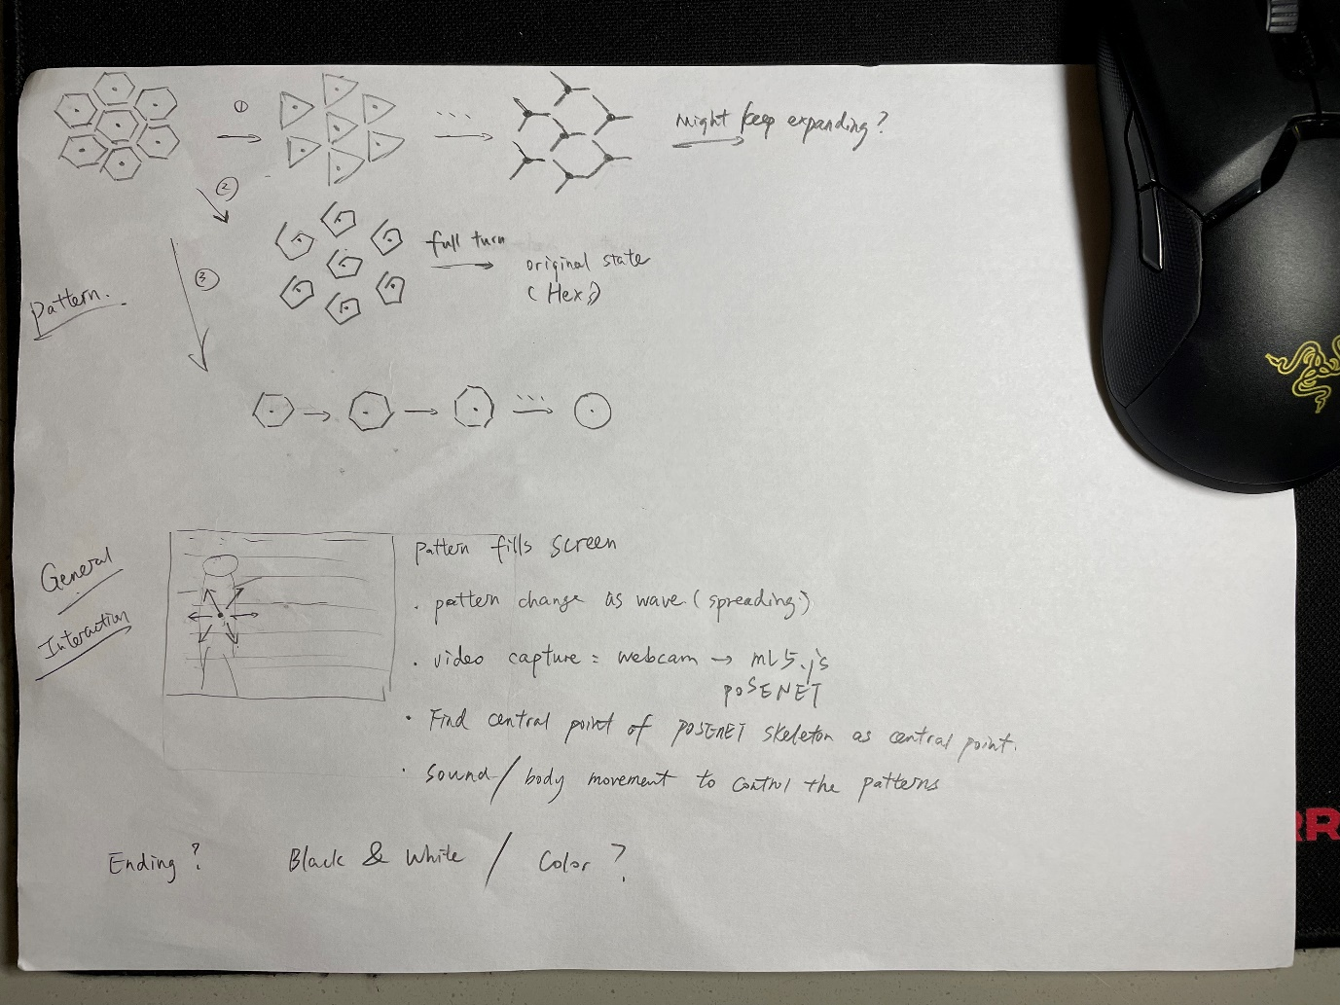

The pattern is basically a tile of hexagons, and each hexagon has three different ways of changing its shape, as lay out in the first part of the sketch. The three ways are differentiated in such a way: the first reduces the number of edges, the second remains the same number of edges and the shape only twist and turns, the third will have its number of edges increase. The sketch does not contain all possible shapes, and I would be willing to add more if time allows. To control the changing of the pattern, I will use ml5.js’s PoseNet to detect the user’s pose from webcam capture and calculate the center point of the user. The center point is then used as the first point that the pattern changes, then the change will spread radially. Then, to control and choose between the three ways of pattern changing, possible triggers are: PoseNet detect the movement of user’s left/right arm, p5.js captures the microphone sound and analyze the amplitude or frequency of user’s voice.

Overall, this project intends to show the interaction between basic geometries and human. It is built on my idea that the foundation of nature are basic geometries, so by interacting with these geometries, users are imitating how ancient people trying to figure out the myth of nature and exploring the possibilities of the geometries to decode the nature. If the project could be presented from a projected screen, the visual might be better.

Some further reflection on the idea:

1. Does the project need an ending scene, or its just the user playing around with the scene?
2. Should it be black & white, or with some color?
3. If the calculated center point moves (user moves), how does the pattern react to that? (i.e., when one pattern is still spreading, should another pattern spreading be initiated? If so, how?)